https://medium.com/@Ashley.Harvey/three-challenges-the-inbound-tourism-industry-in-japan-needs-to-overcome-to-sustain-its-growth-d3ab1ba08cb2

Original by Ashley Harvey

Published on medium.com

Jan 4, 2018

Adapted for EFL

1021 words.

Three Challenges for Japan’s Inbound Tourism Marketing
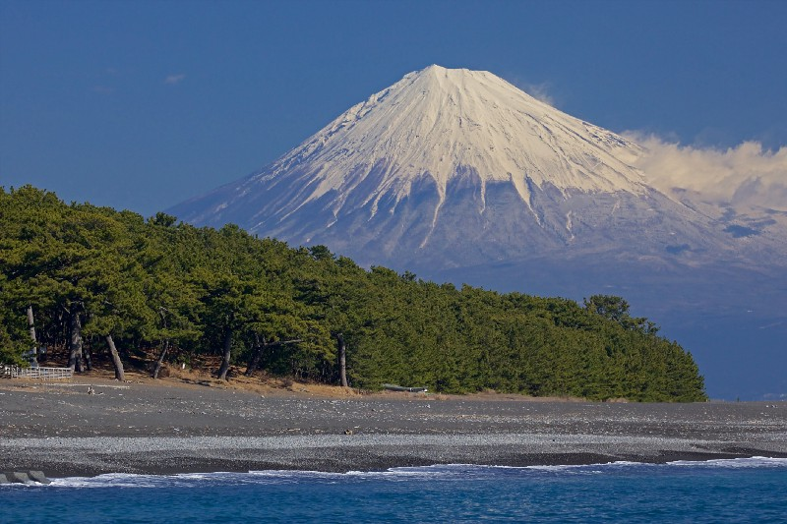Inbound tourism in Japan is growing fast. Two years ago, there were about 24 million foreign visitors. Last year, that number was reached in October.
Now we assume that inbound tourism numbers will grow every year. Few developed nations have ever had such fast growth in tourism. It is easy to forget that not too long ago, the government didn’t think much about tourism.

Central Government steps in…

In December 2012 Prime Minister Abe was elected and he promised change. He promised ‘Abe-nomics’. The yen dropped about 33% against major currencies* in a very short time. This made things in Japan cheaper for foreigners.

* NOTE: * means look at the bottom of the article for the meaning.

The government made visa requirements easier for many Southeast Asian nations and for for China.

In September 2013, Tokyo was made the host for the 2020 Olympics. The PR was clear. Japan was popular. Talk in the media became a positive one. Japan was cheaper, easier the get to and a good news story. The tourists began to arrive.

Local government officials were surprised. Prefectures such as Ishikawa, Hokkaido and Okinawa were ready. They were in a strong position to capitalize.*

Most tourism offices, however, were (and still are) controlled by local governments. That means mostly males in their late 50’s with little or no international experience.

This leads neatly to the first challenge…

1. Professionalization
Tourism marketing has been a professional vocation for the rest of the world for many years.
In the early 1990’s a few smart governments understood the importance of tourism. They also recognized that governments were not the best at marketing. They created Destination Marketing Organizations (DMO’s). These paired government funding* with private-sector* marketing skills. The basic format was successful. By the end of the 1990’s DMO’s became an important part of global tourism promotion (except in Japan).
The Japanese government saw successful DMO’s around the world. In a very late response, in 2014 it began creating DMO’s. Now, everywhere in Japan seems to be covered by a DMO. However, the DMO’s in Japan are largely still managed by staff from the government. The name has changed but not much else.

Japan’s DMO’s are staffed, not by a small team of professionals, but by a large team of government workers. The staff are “lent” to the DMO other government offices for up to 2 years. It is rare for the staff to have any tourism experience.

With little experience, staff struggles to do tourism marketing. They don’t know the basics such as social media, marketing, & tourism development. And if a staff member happens to know a foreign language, they end up translating brochure after brochure.
Japanese staff at DMO’s are hard working. It must be frustrating for them to see all of their hard work create few results.
DMO’s in Japan need to professionalize quickly. Global tourism marketing is very competitive. Right now the growth in tourism numbers hides the fact Japan is not able to compete.

Let’s not forget however that inbound tourism is a new industry in Japan.
One short-term solution is to bring in professionals from around the world to manage projects. The role of the foreign talent should also be to train the Japanese staff to bring Japan into the modern era.

A longer term solution has to be Japan develops its own talent. This development means a big change in the way foreign languages are taught in school. Japan should also develop digital marketing courses, tourism development courses, sustainable tourism* courses etc. at colleges and universities.

2. Diversification*

If you step into a tourism association meeting anywhere in Japan you will see only a few women. As for foreigners? Perhaps an ex-JET teacher who got a job at the local DMO.

Yet foreign tourists are diverse. One of VisitBritain’s strengths is their diversity of its staff. Male, female. Gay, straight. Asian, African. Gen X, millennial. Lots of different kinds of people are there.
The staff of VisitBritain are a good reflection of the people visiting Britain. Working in such a diverse workforce is an absolute joy.
The same cannot be said for Japan. The late-middle-aged Japanese male dominates the entire industry. Not just DMO’s. The same is true for domestic tourism. Having little diversity makes it hard for Japan to compete globally.

Is it any surprise therefore that Japanese tourism promotion hasn’t been successful? Rather than explore the country, tourists go to Tokyo and Kyoto. These are the only cities they know of.

Japan’s regional DMO’s would find quick success if their marketing focused more travelers. To do this, decision making needs to be done from the view point of a tourist. It’s therefore a pretty good idea to have people from different backgrounds working in your DMO!

3. Digitalization

The future of tourism marketing is not digital marketing. Tourism marketing has been digital for the last 10 years or so. Japan must wake up to this. So much tax payer’s money is wasted on printed materials. These end up in the trash can. Many areas of Japan are digitally invisible.

To the modern traveler, researching their next trip, digital information is the one of the key sources of information. If your destination or property is not on Yelp! or TripAdvisor you don’t exist. If you don’t exist, no-one will visit. What is the point of all the brochures you made to put in your Tourism Information Center (TIC)?

Digital marketing should be the foundation of all the work DMO’s do. Offline events should support the digital work not the other way around.
Across the country Japan desperately needs to light up its digital map. A country which stretches nearly 3,000km from Hokkaido to Okinawa should be a tourism giant. It has incredible powder snow skiing, white sand beaches, world class museums all connected by clean, fast and efficient transportation.
Japan is every tourism marketing professionals dream. It really has so much to offer. It is time for Japan to step up and step into the present … and the future.

Now that you’ve read this, try to read the original:

https://medium.com/@Ashley.Harvey/three-challenges-the-inbound-tourism-industry-in-japan-needs-to-overcome-to-sustain-its-growth-d3ab1ba08cb2

Easier: Just google:
medium.com Ashley Harvey inbound marketing

*
currencies = types of money (yen, dollar, euro, pound, etc.)
capitalize = to take advantage of this situation. They got more tourists. They made money from it.
funding = money
private sector = private companies, not the government
sustainable tourism = tourism that will last many years.
diversification = to be made up of many different kinds of people.

