Box x.1 Power Poses Student A

How you hold your body can make a difference in how you feel.
This affects your mood and confidence

Work with a partner.
Tell your partner how to stand in this position. Don’t show the picture.
You stand in this position, too.
What to say:

This position is called Wonder Woman or Superman.
They are super heroes like you see in movies.

You might want to close your eyes.
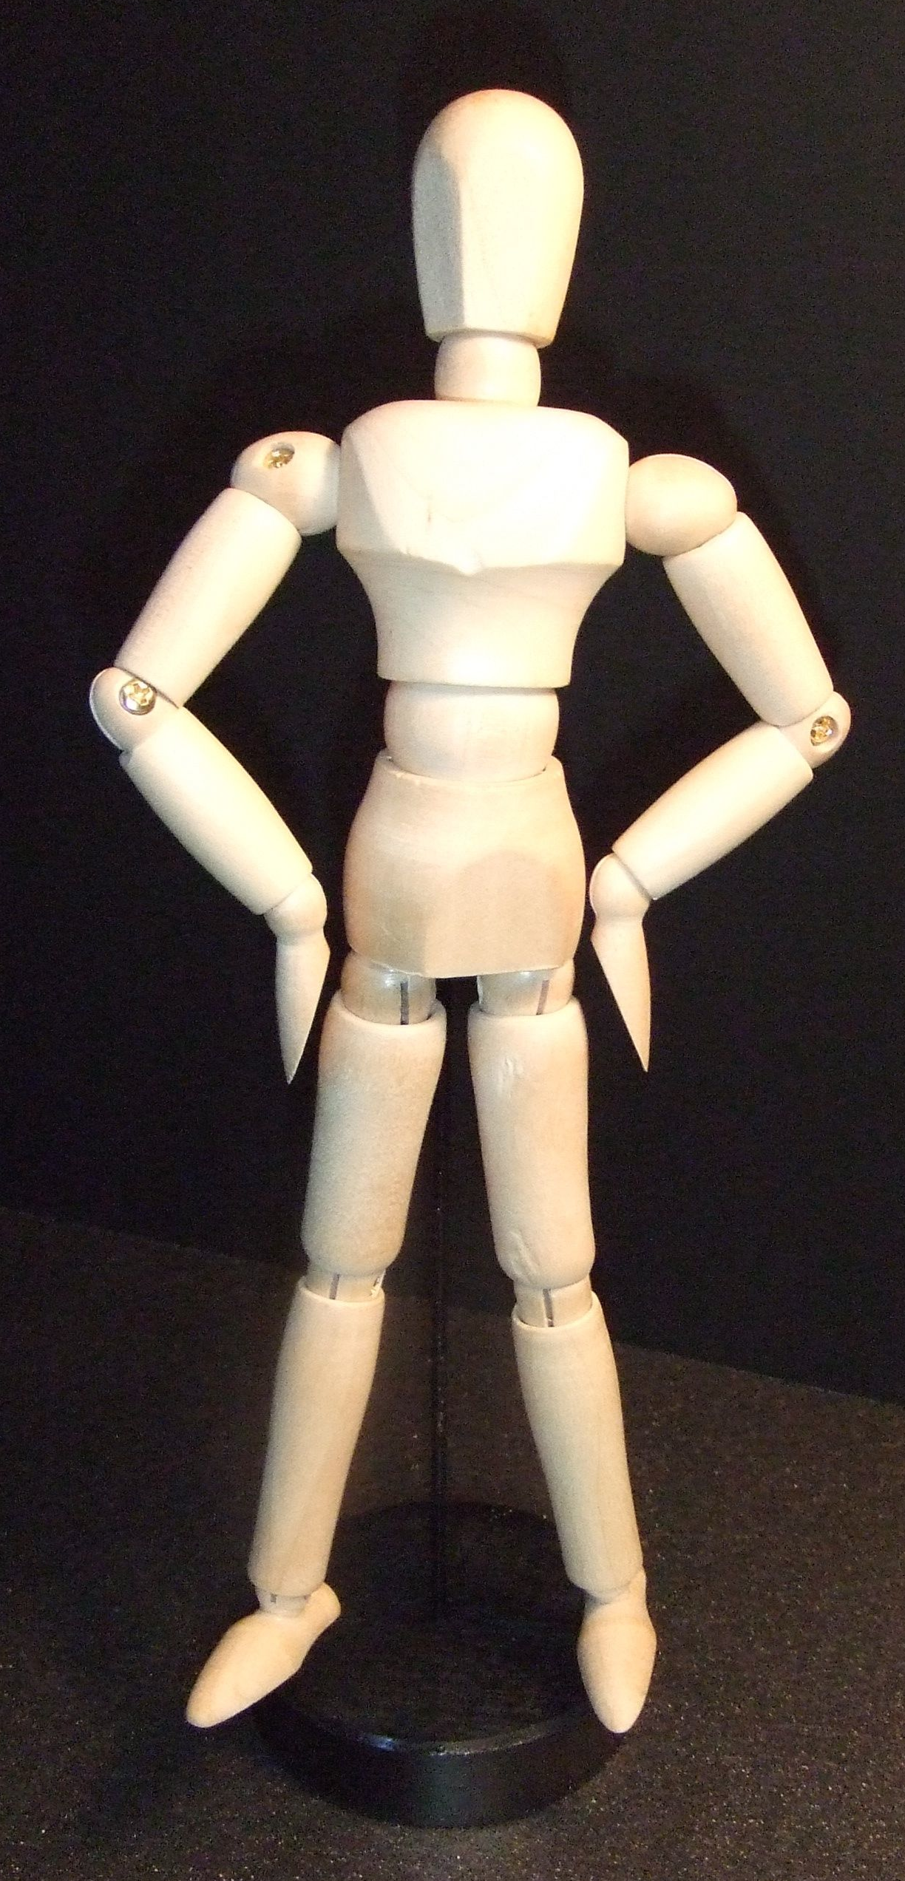

Stand with your feet about
45 centimeters* apart. (* 45 cm = 18 inches)
Stand up straight.
Push your chest out.
Hold your head up a little.
Put your hands on your waist.
Hold your elbows out.
Take a deep breath.

Keep this position for one minute.
Then say:

Notice your body. How do you feel?
Notice your breathing. Is it fast or slow?
Notice your muscles.
Your stomach.
Your chest.
Your shoulders and arms.
Your neck.
Your head.

Notice your feelings.
Do you feel strong?
Do you feel confident?
Do you feel powerful?

If this “power pose” makes you feel good,
you can use it any time you want to feel this way.

Learn your partner’s “Power Pose.”
Then change partners. Learn a different “Power Pose.”

© Cambridge University Press 201x PHOTOCOPIABLE

Box x.2 Power Poses Student B

How you hold your body can make a difference in how you feel.
This affects your mood and confidence

Work with a partner.
Tell your partner how to stand in this position. Don’t show the picture.
You stand in this position, too.
What to say:

This position is called King or Queen of the world.

You might want to close your eyes.
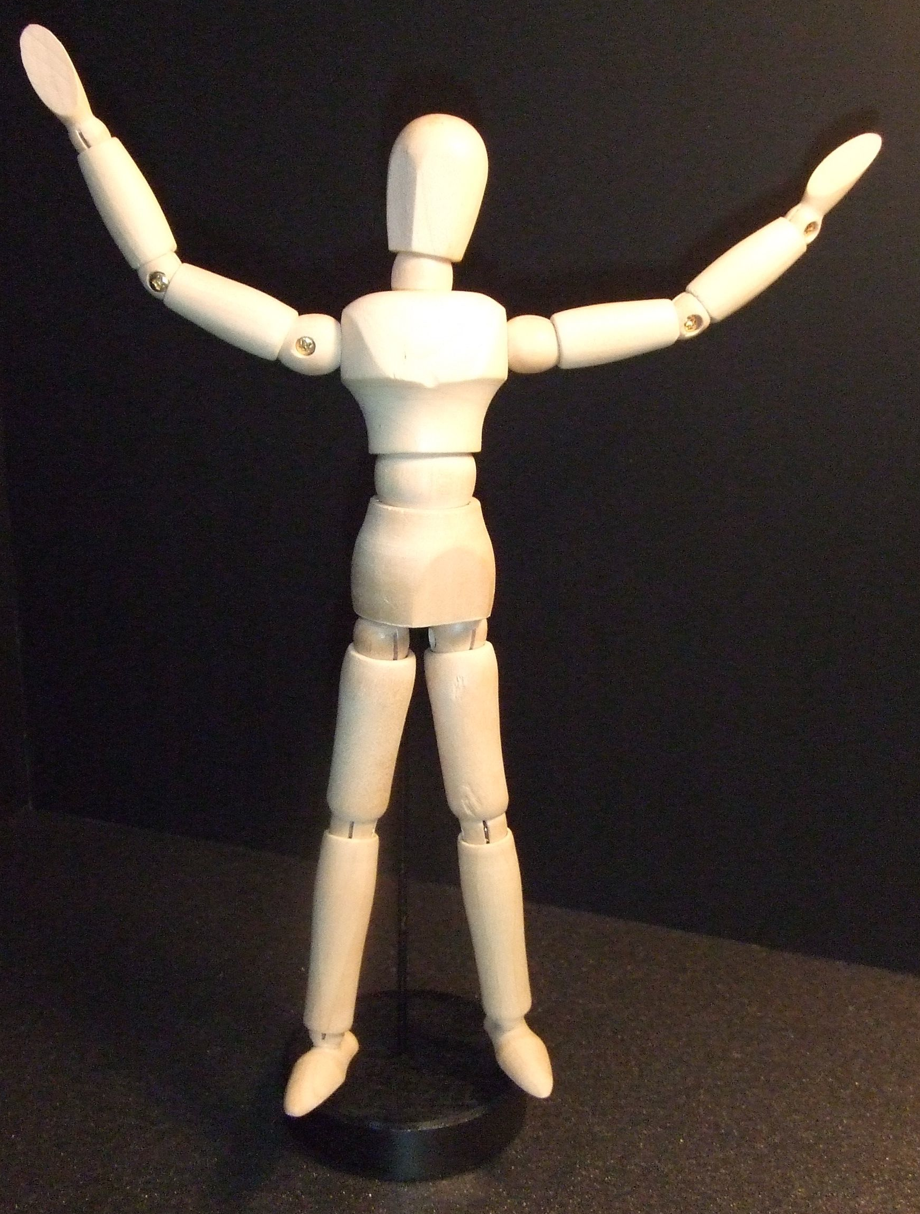

Stand with your feet about
45 centimeters* apart. (* 45 cm = 18 inches)
Stand up straight.
Push your chest out.
Hold your head up a little.
Hold your arms out to your side.
Raise your hands up.
Take a deep breath.
You are “King (Queen) of the world.”
Maybe you are going to hug the world!

Keep this position for one minute.
Then say:

Notice your body. How do you feel?
Notice your breathing. Is it fast or slow?
Notice your muscles.
Your stomach.
Your chest.
Your neck.
Your head.
Your shoulders and arms.

Notice your feelings.
Do you feel strong?
Do you feel confident?
Do you feel powerful?

If this “power pose” makes you feel good,
you can use it any time you want to feel this way.

Learn your partner’s “Power Pose.”
Then change partners. Learn a different “Power Pose.”
© Cambridge University Press 201x PHOTOCOPIABLE
Box x.3 Power Poses Student C

How you hold your body can make a difference in how you feel.
This affects your mood and confidence

Work with a partner. Tell your partner how to stand in this position.
Don’t show the picture. You stand and gesture, too.
What to say:

This position is called Lean In.
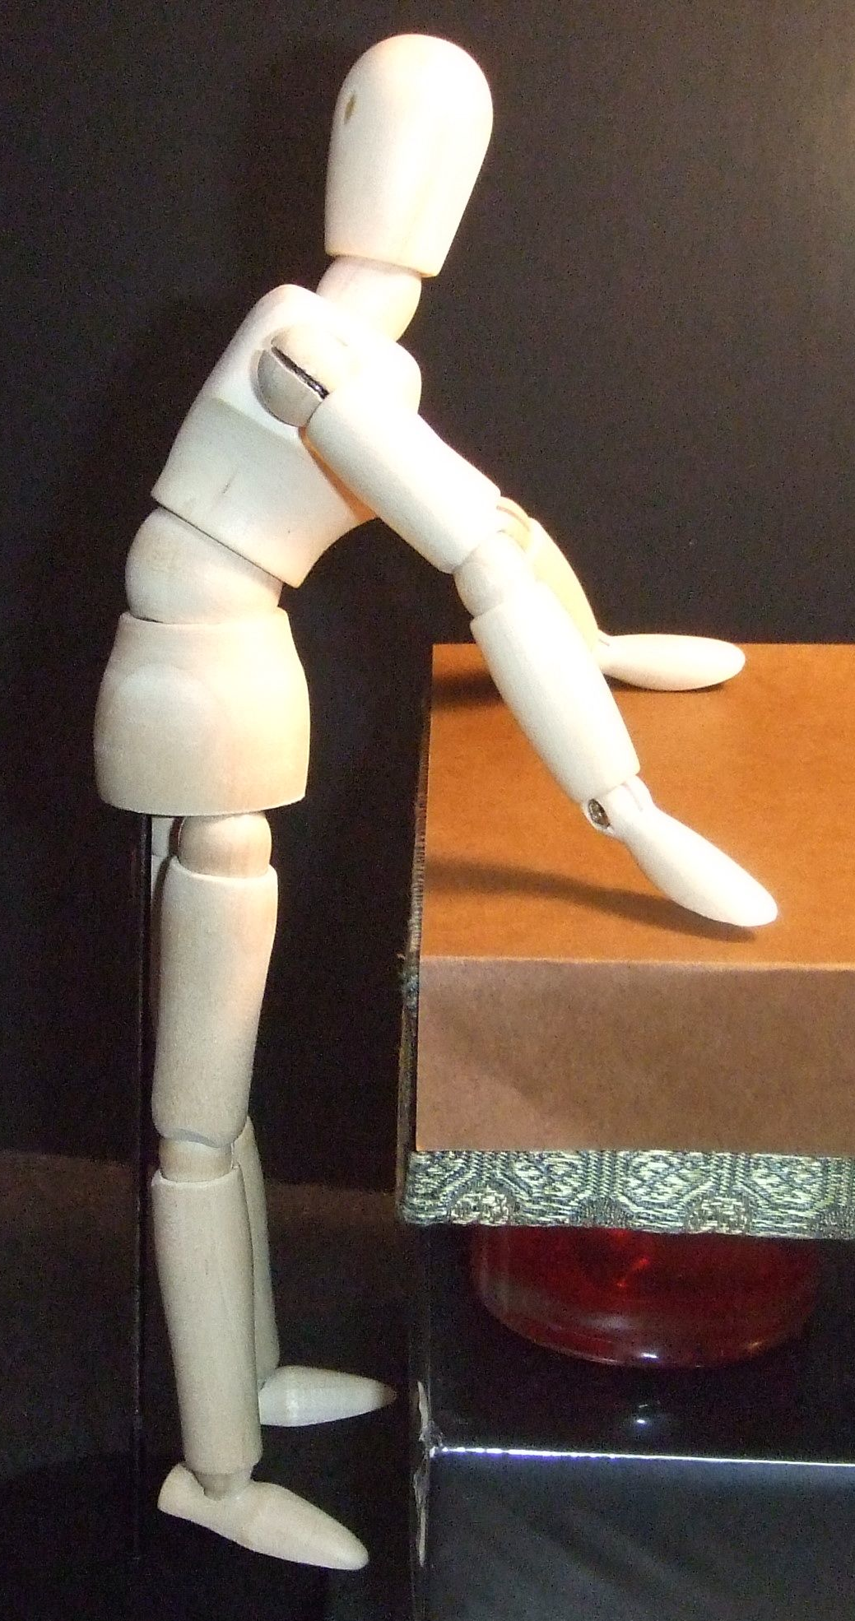
Speakers use it for presentations.

You might want to close your eyes.
Imagine you are giving a speech
Stand with your feet about
45 centimeters* apart. (* 45 cm = 18 inches)
Stand up straight.
Push your chest out.
Put your hands on the table about
60 centimeters* apart. (* 45 cm = 2 feet)
Lean your head and body in.
Gesture. Make large movements
with each hands.
Take a deep breath.

Keep this position for one minute.
Then say:

Notice your body. How do you feel?
Notice your breathing. Is it fast or slow?
Notice your muscles.
Your stomach.
Your chest.
Your shoulders and arms.
Your neck.
Your head.

Notice your feelings.
Do you feel strong?
Do you feel confident?
Do you feel powerful?

If this “power pose” makes you feel good,
you can use it any time you want to feel this way.

Learn your partner’s “Power Pose.”
Then change partners. Learn a different “Power Pose.”

© Cambridge University Press 201x PHOTOCOPIABLE
Box x.4 Power Poses Student D

How you hold your body can make a difference in how you feel.
This affects your mood and confidence

Work with a partner.
Tell your partner how to stand in this position. Don’t show the picture.
You stand in this position, too.
What to say:

This position is called Victory.
You see it when someone wins a race.

You might want to close your eyes.
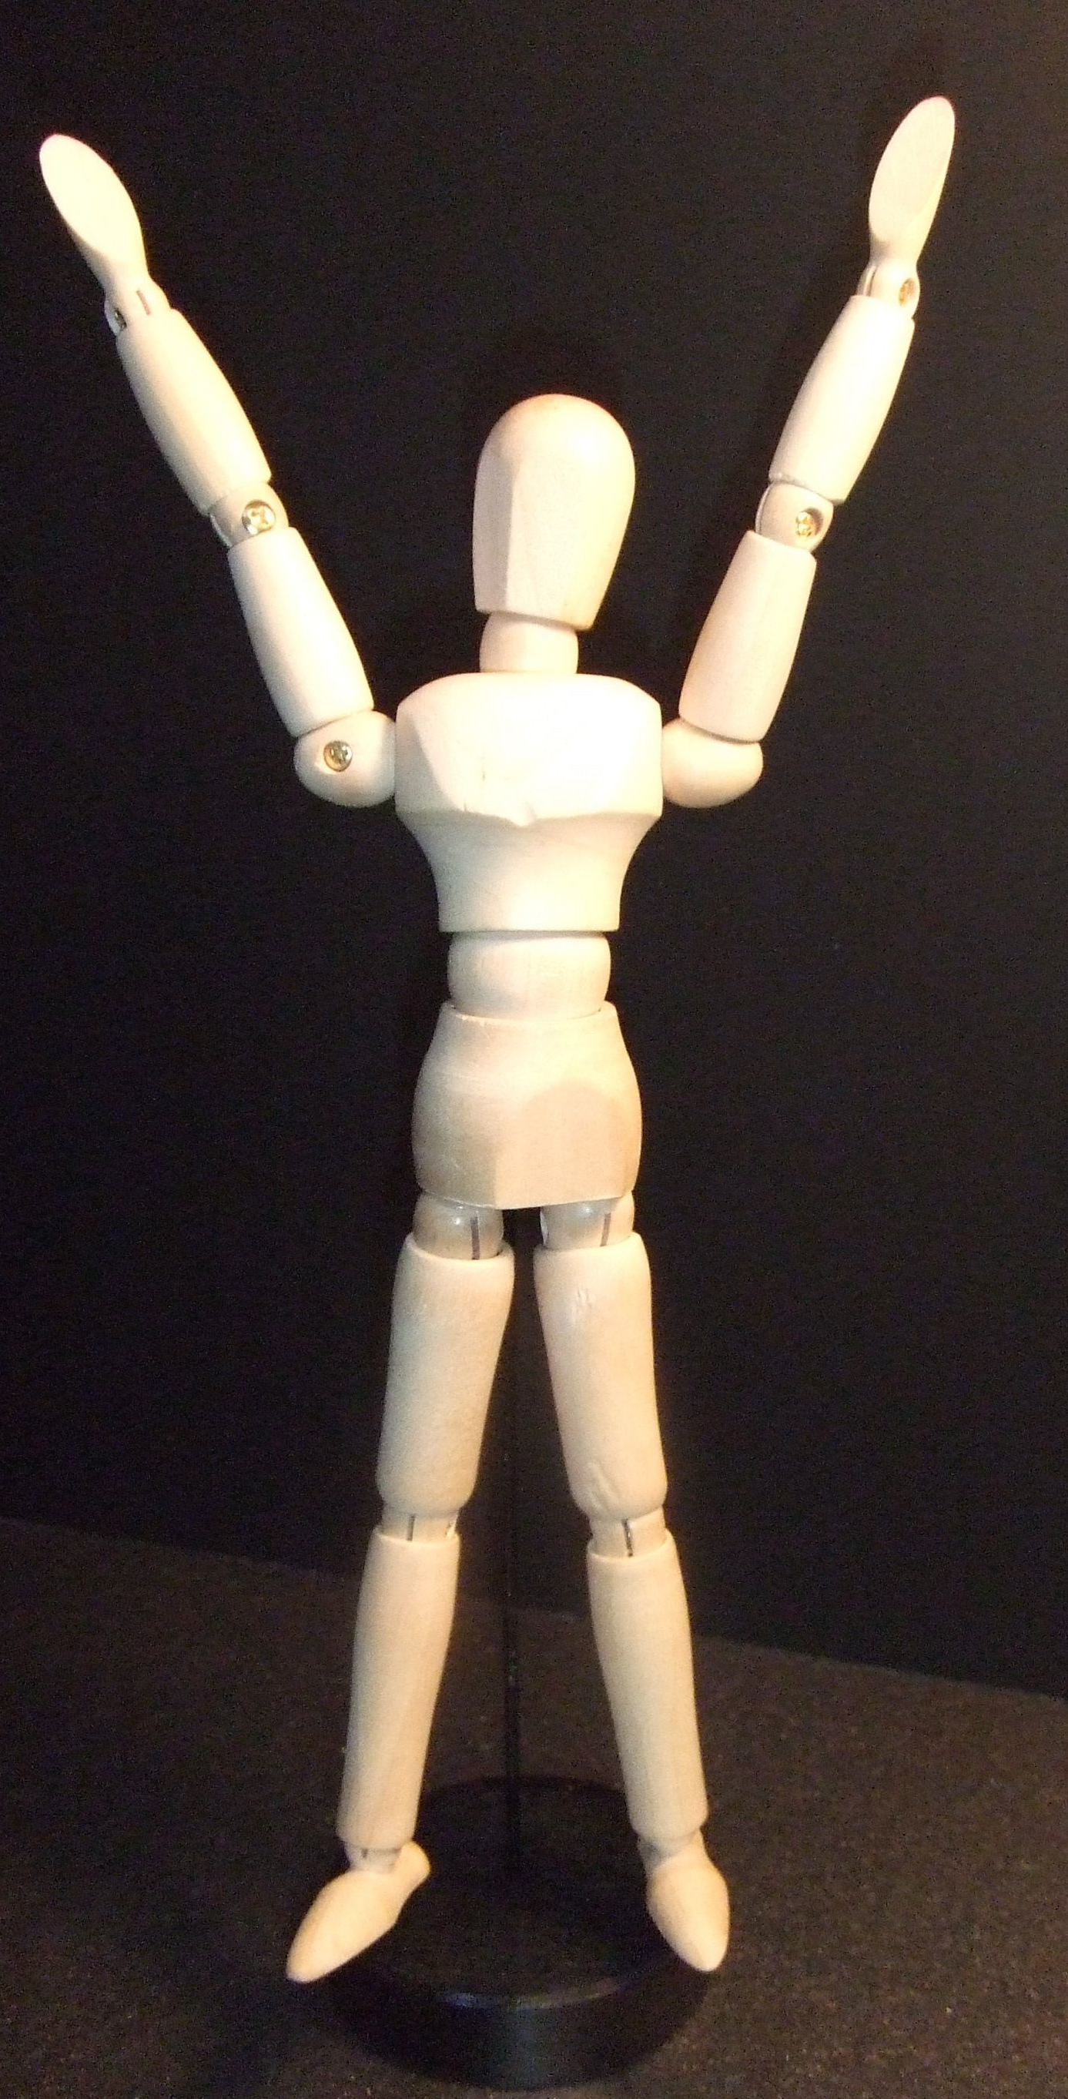

Stand with your feet about
45 centimeters* apart. (* 45 cm = 18 inches)
Stand up straight.
Push your chest out.
Hold your head up a little.
Put your hands above your head.
They look like a large letter “V.”
Take a deep breath.

Keep this position for one minute.
Then say:

Notice your body. How do you feel?
Notice your breathing. Is it fast or slow?
Notice your muscles.
Your stomach.
Your chest.
Your neck.
Your head.
Your shoulders and arms.

Notice your feelings.
Do you feel strong?
Do you feel confident?
Do you feel powerful?

If this “power pose” makes you feel good,
you can use it any time you want to feel this way.

Learn your partner’s “Power Pose.”
Then change partners. Learn a different “Power Pose.”

© Cambridge University Press 201x PHOTOCOPIABLE

